contents

Product Overview 2

User Story 3

Index Page 3

Home Page 3

User Register Page 3

Airbnb Booking Page 4

Blog Page 4

Blog List Page 4

Blog Detail Page 5

Q&A Page 6

Admin Page 6

Admin Login Page 6

Admin Register Page 7

Use Case Design 8

Gantt Chart 9

Technical Specification 11

Deployment Strategy 11

# Product Overview

This is a travel-themed blog website with the URL [www.journey-nci.xyz](https://www.journey-nci.xyz) or [journey-nci.xyz](https://journey-nci.xyz). If you use an HTTP request or access the above two domain names without any prefix, it will automatically redirect to the HTTPS URL.

The website contains 5 parts. The 1st part is home page. This page shows the real time weather information for the current location on its left part. On the right part, it provides a login interface.

If user doesn’t have an account, he can click the “register” button and open the registration page. User should use a never used username to register. If the username is used, it will remind users to change another one.

The 2nd part is Airbnb room queries page. Users can query Airbnb rooms by location, check-in and check-out date, adult quantity, and other conditions. The page will show a list of room information and link which connects to the website of Airbnb.

The 3rd part is blog list. User can browse all blogs and publish new blog or publish comment under a blog. User can also edit or delete his own blog.

The 4th part is the artificial intelligence question and answer page. User can ask any questions to the AI and get answers.

The last part is admin module. In practical applications, this part should be an internal web page that can only visited by staff. Staff can register and login an account, delete inappropriate blogs and inappropriate comments.

# User Story

## Index Page

### Home Page

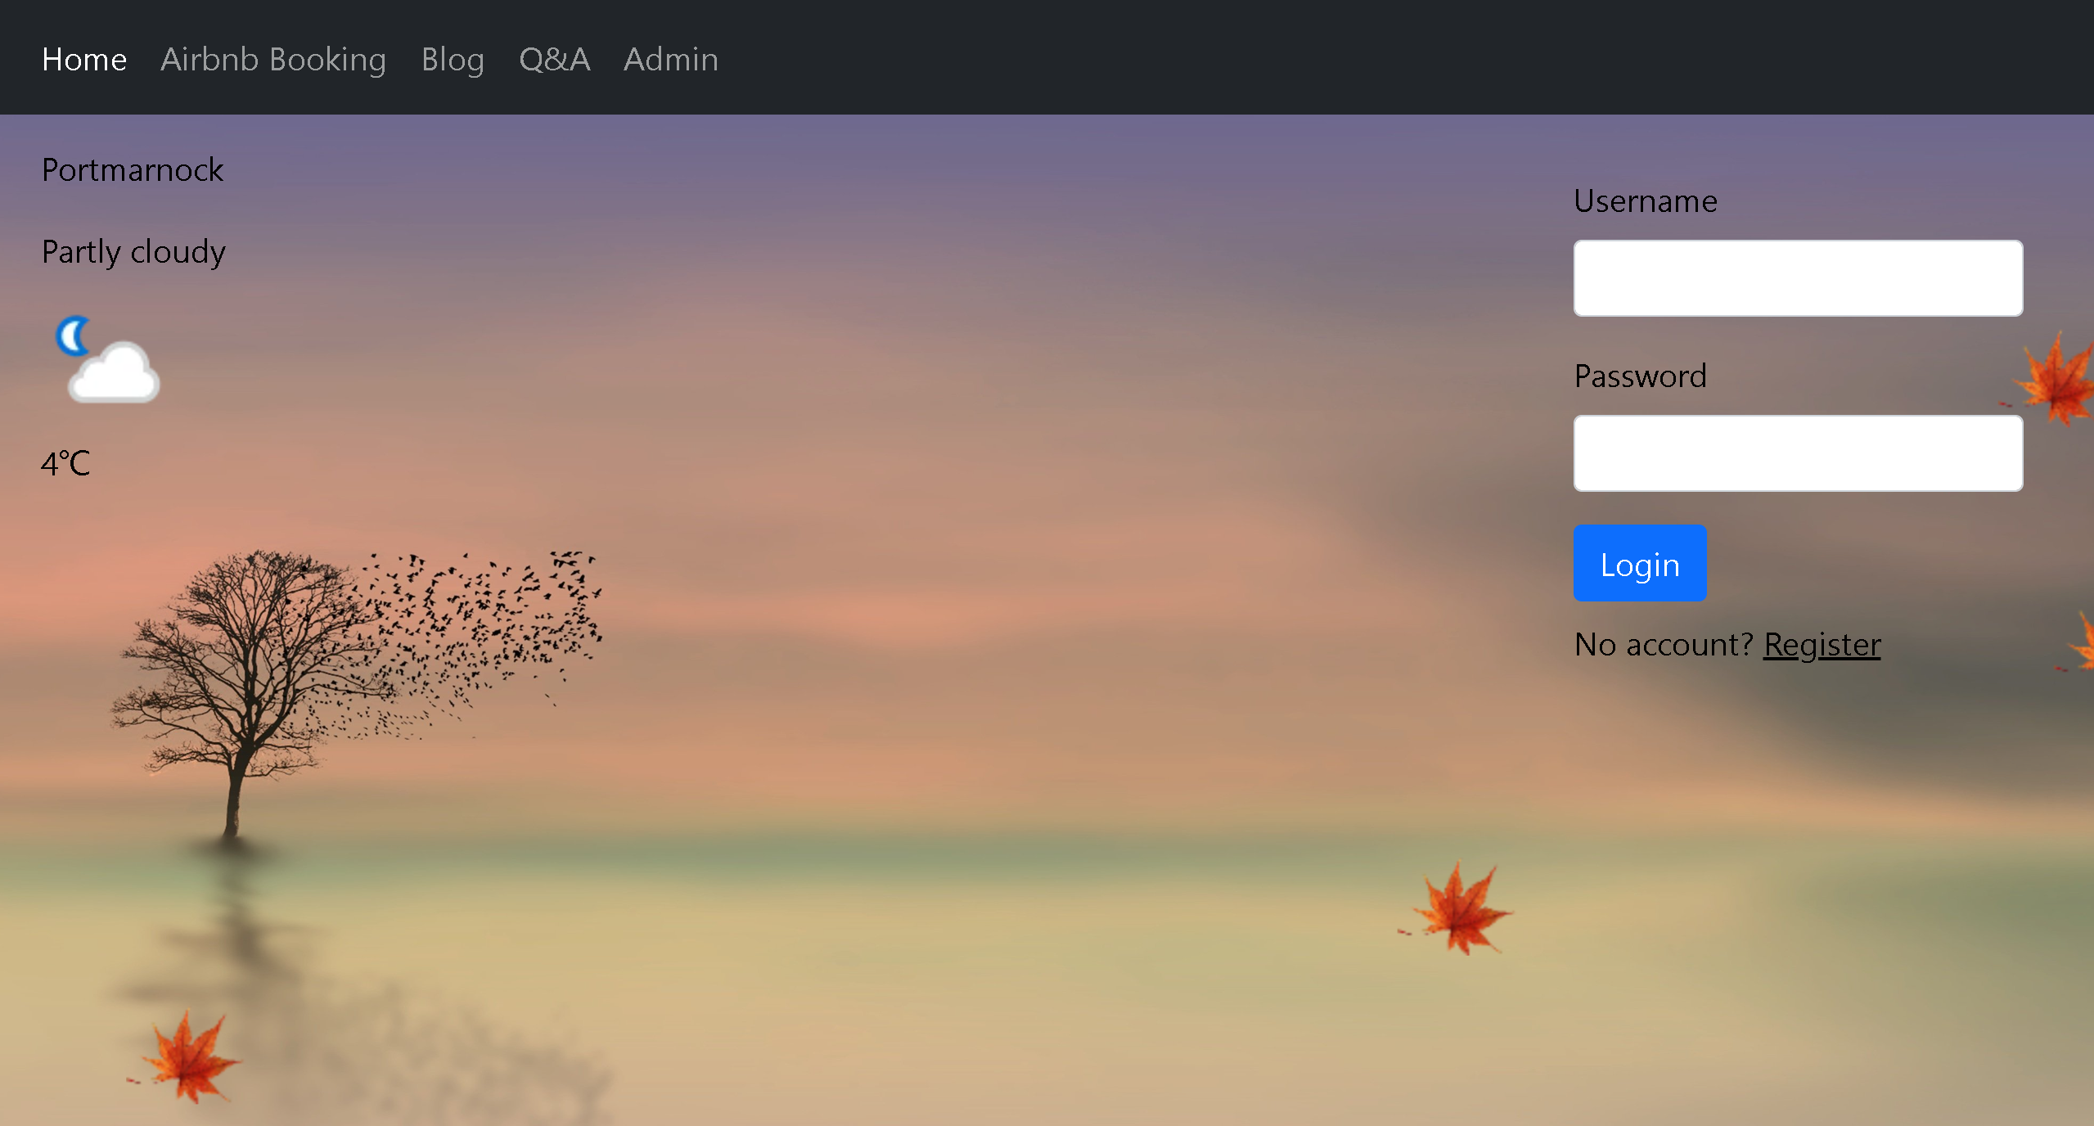

### User Register Page

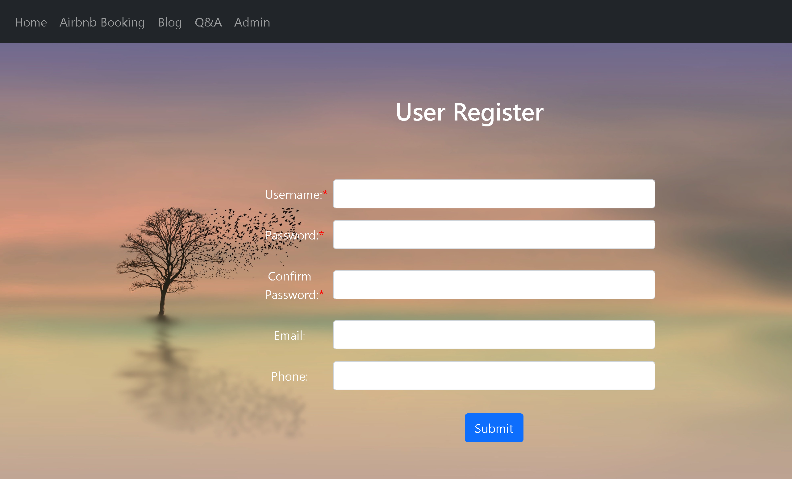

## Airbnb Booking Page

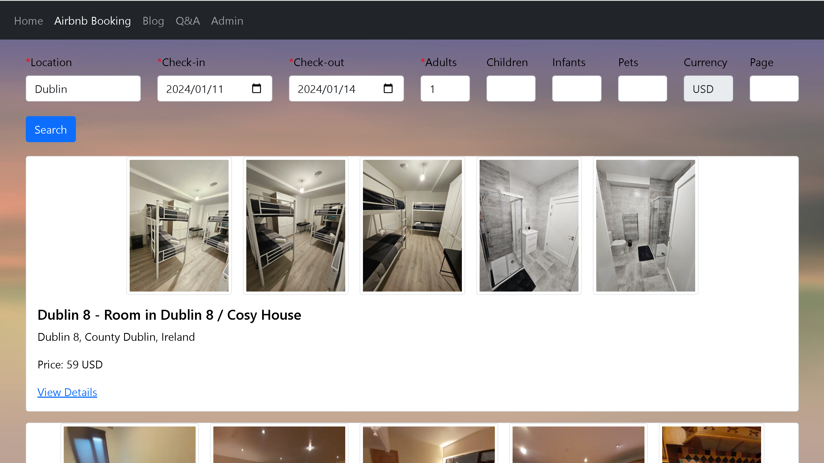

## Blog Page

### Blog List Page

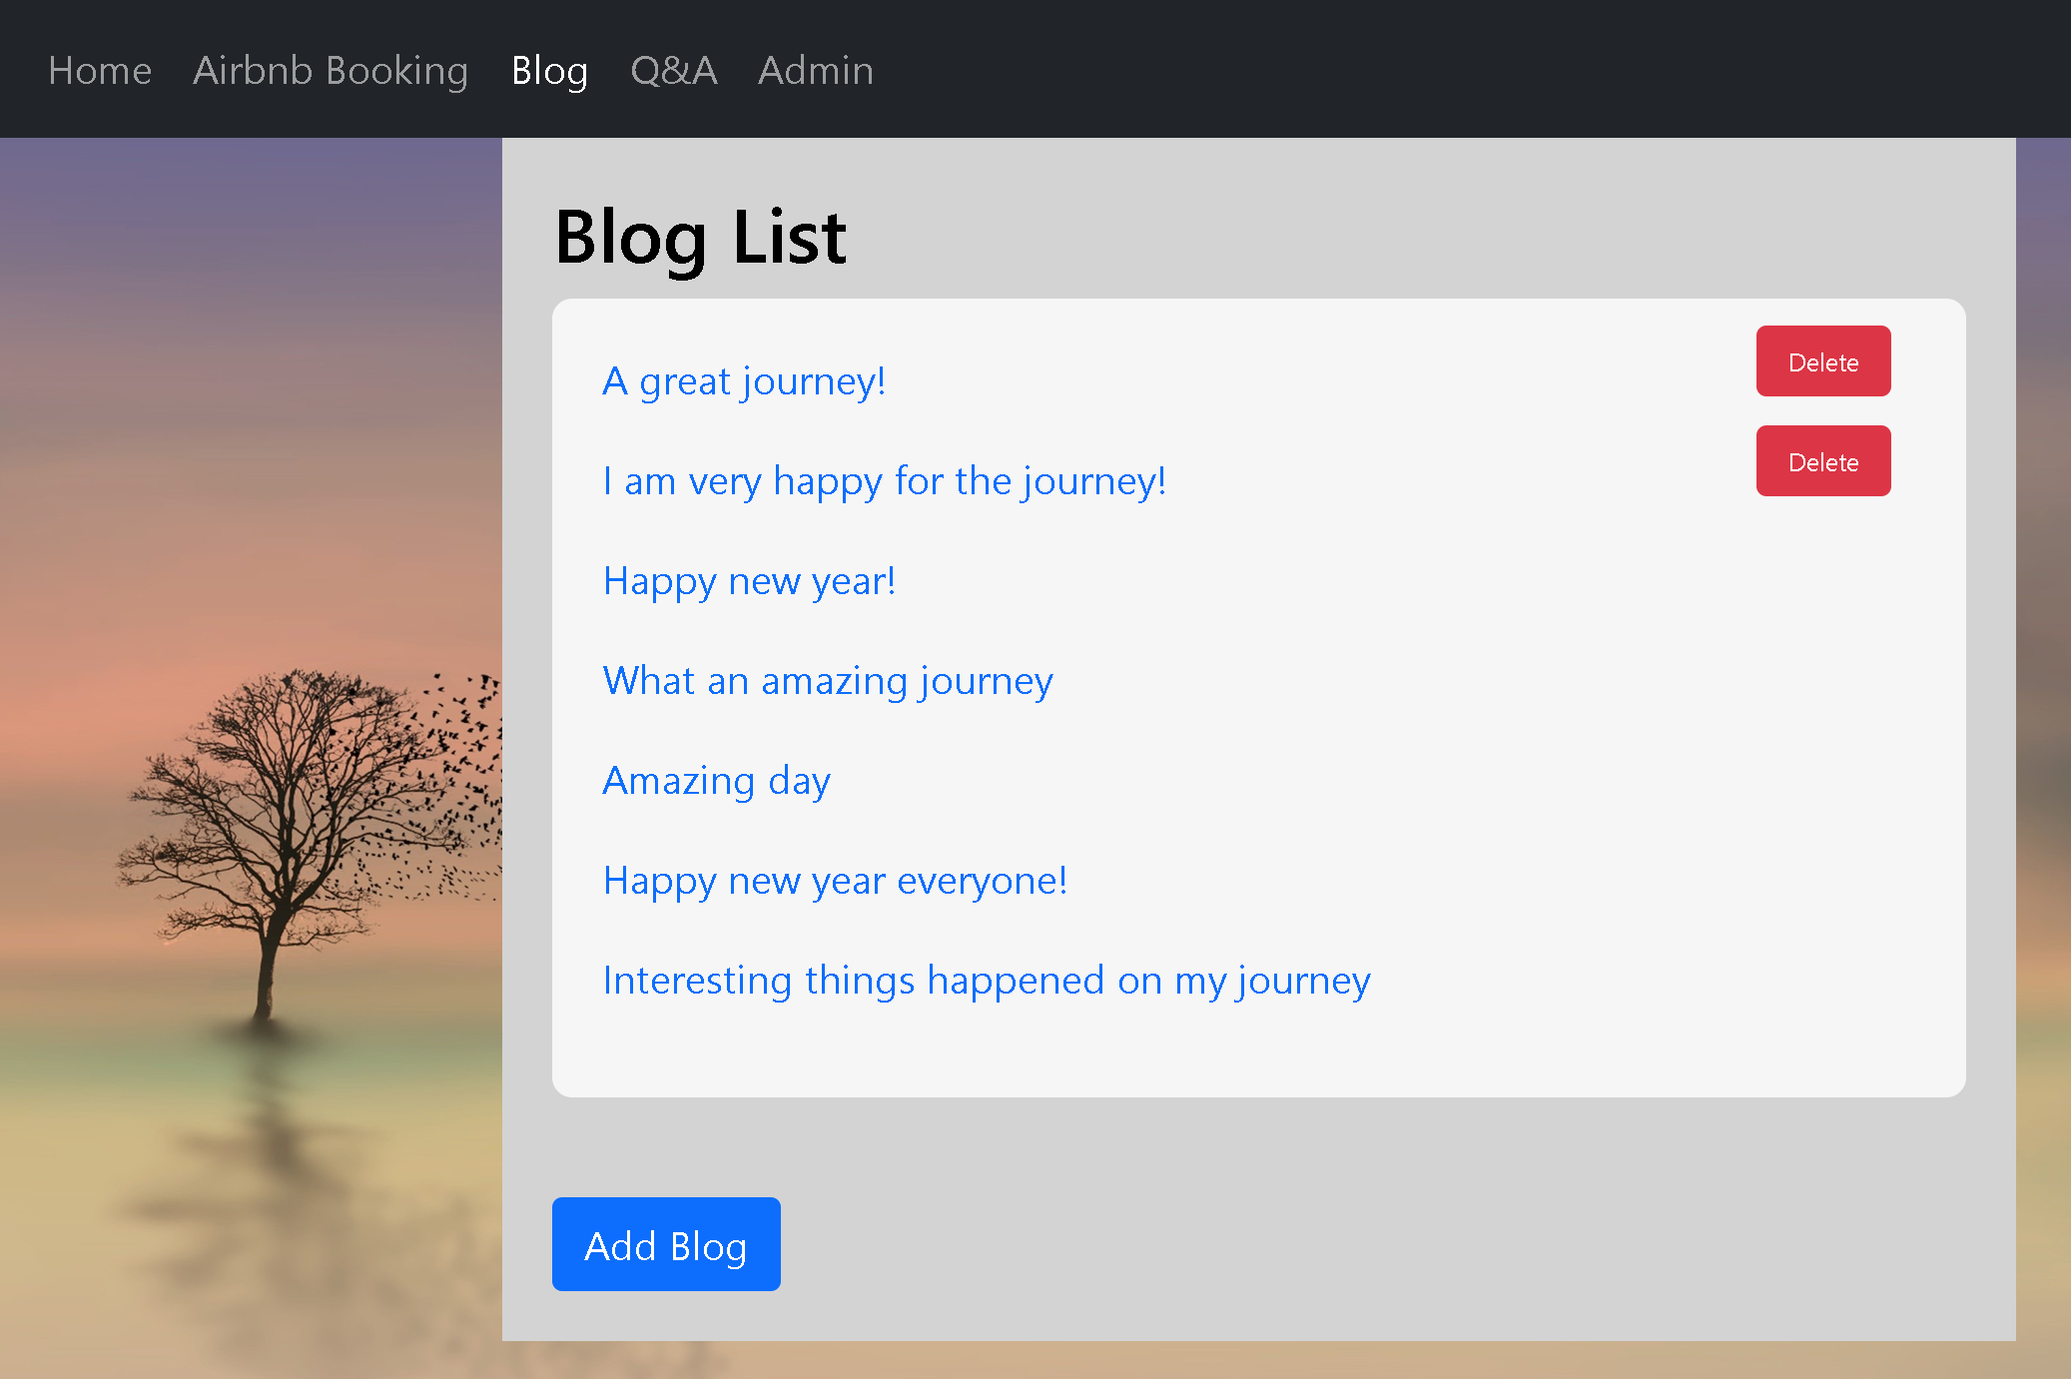

### Blog Detail Page

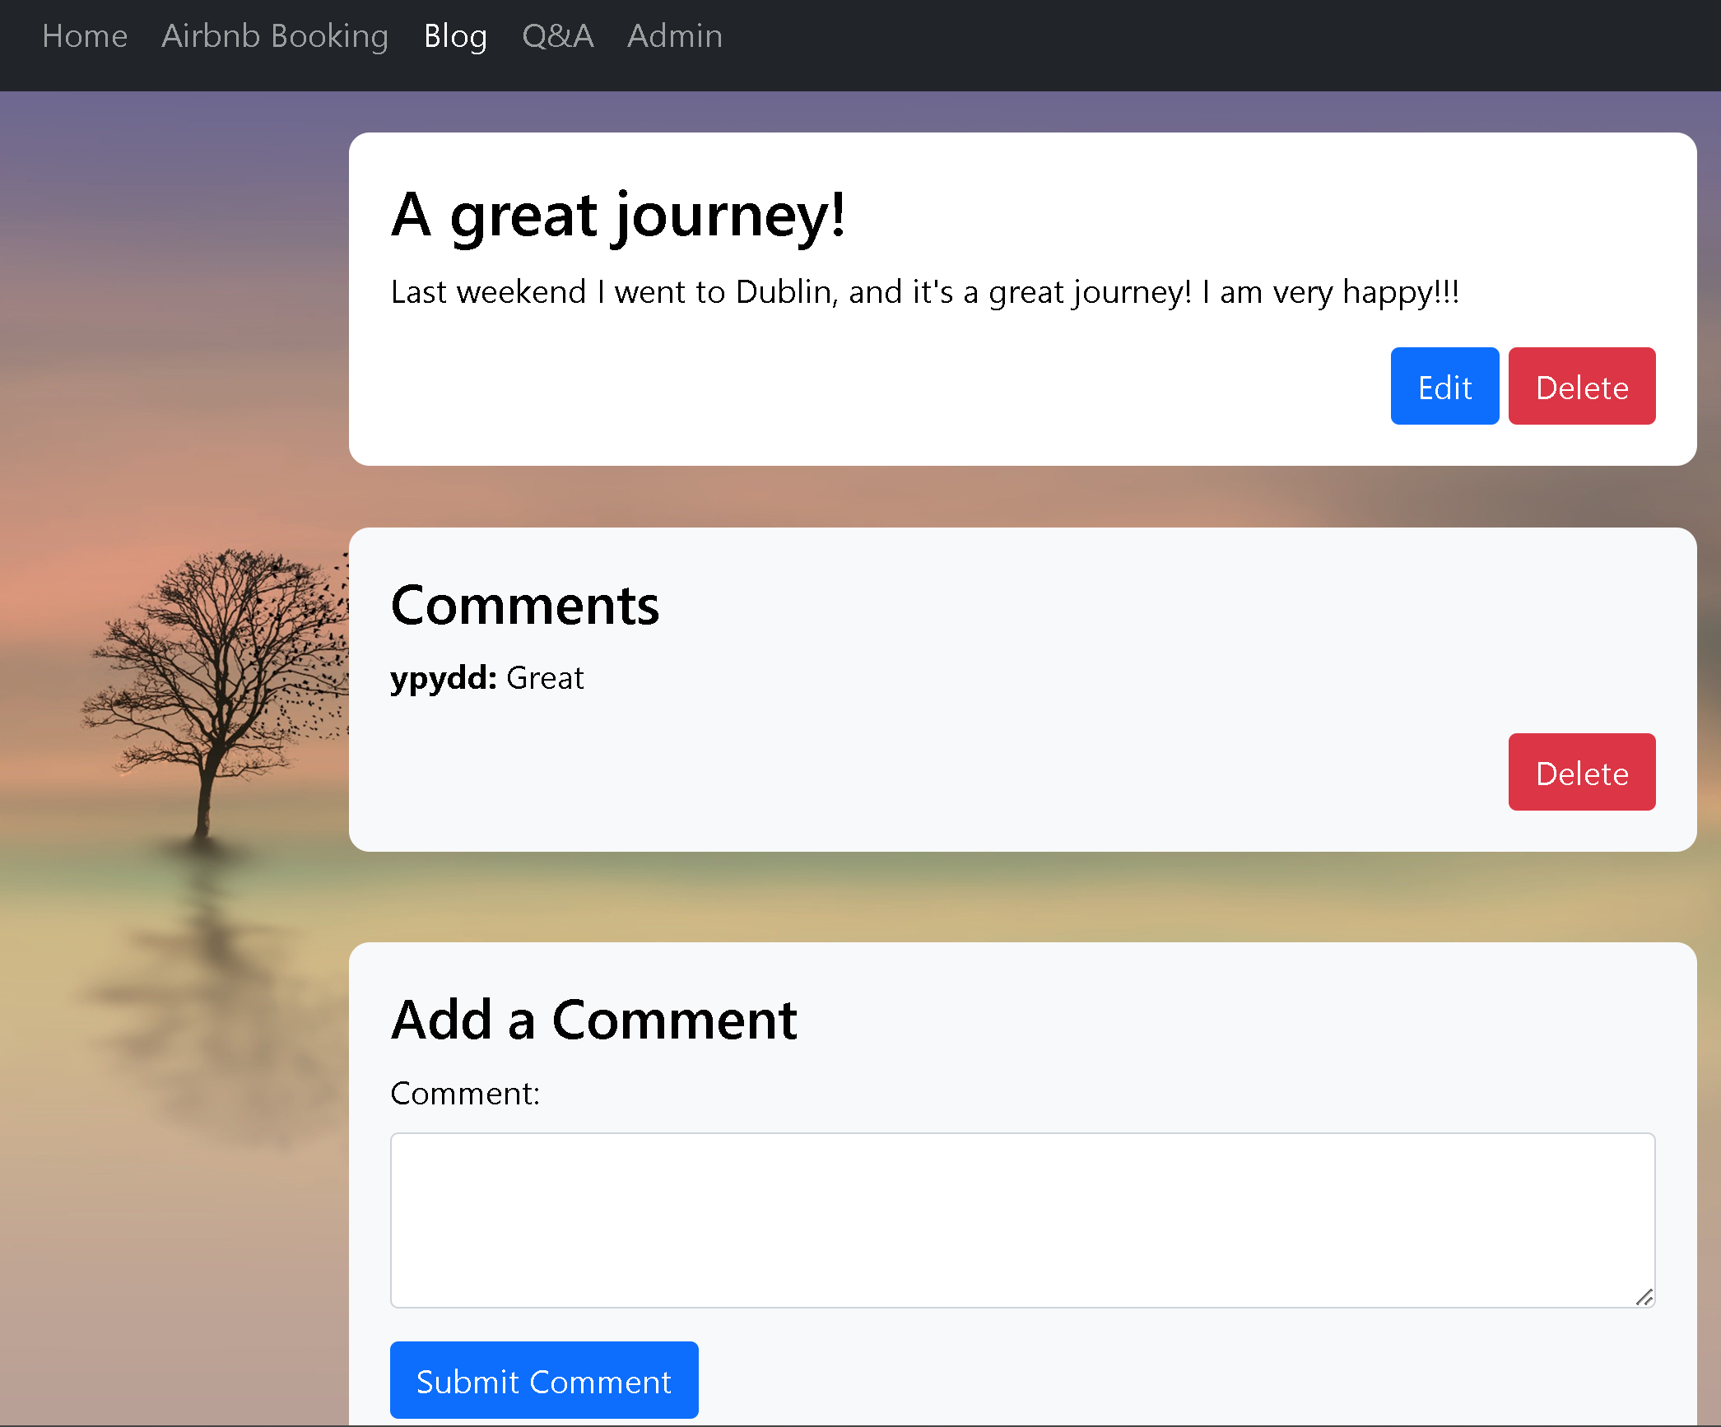

## Q&A Page

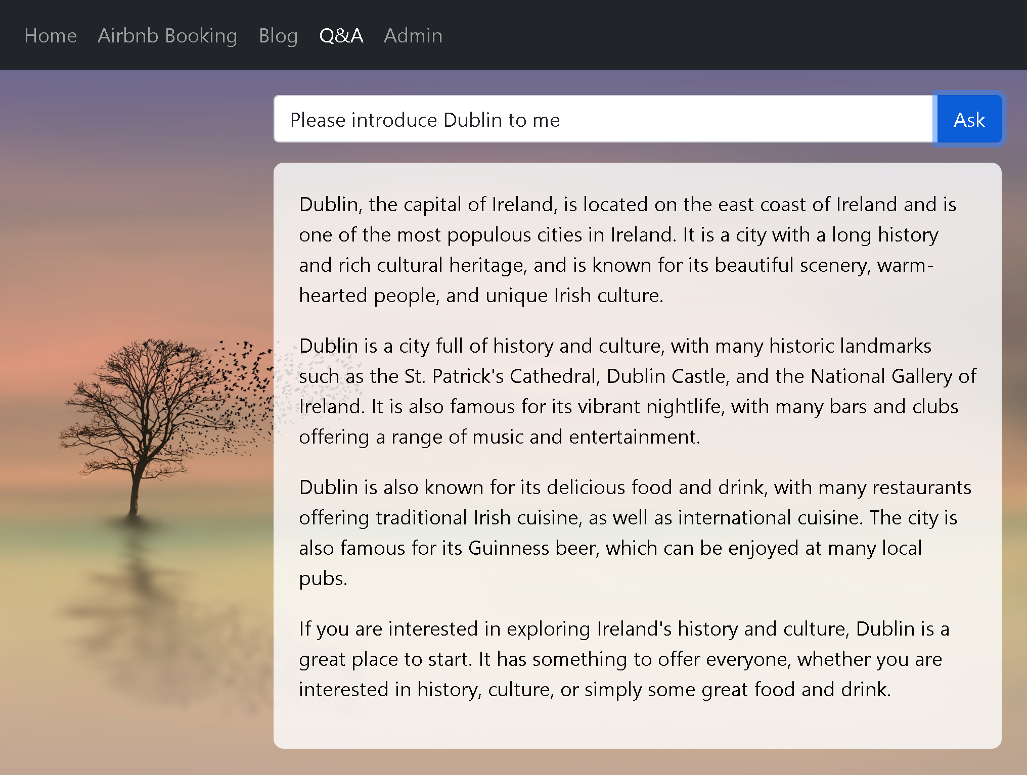

## Admin Page

### Admin Login Page

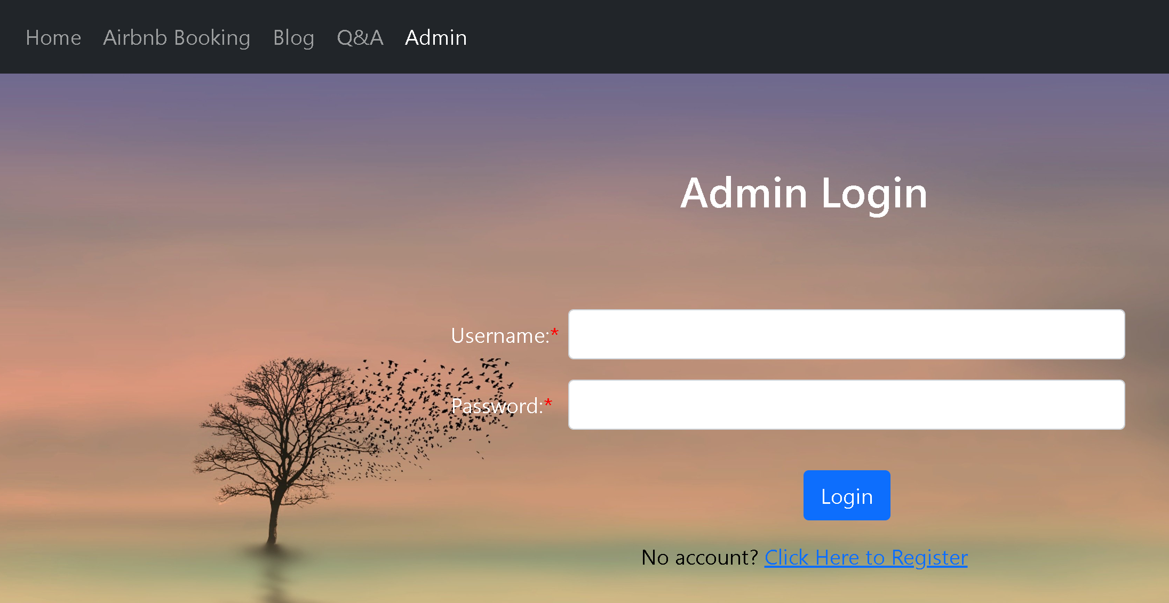

### Admin Register Page

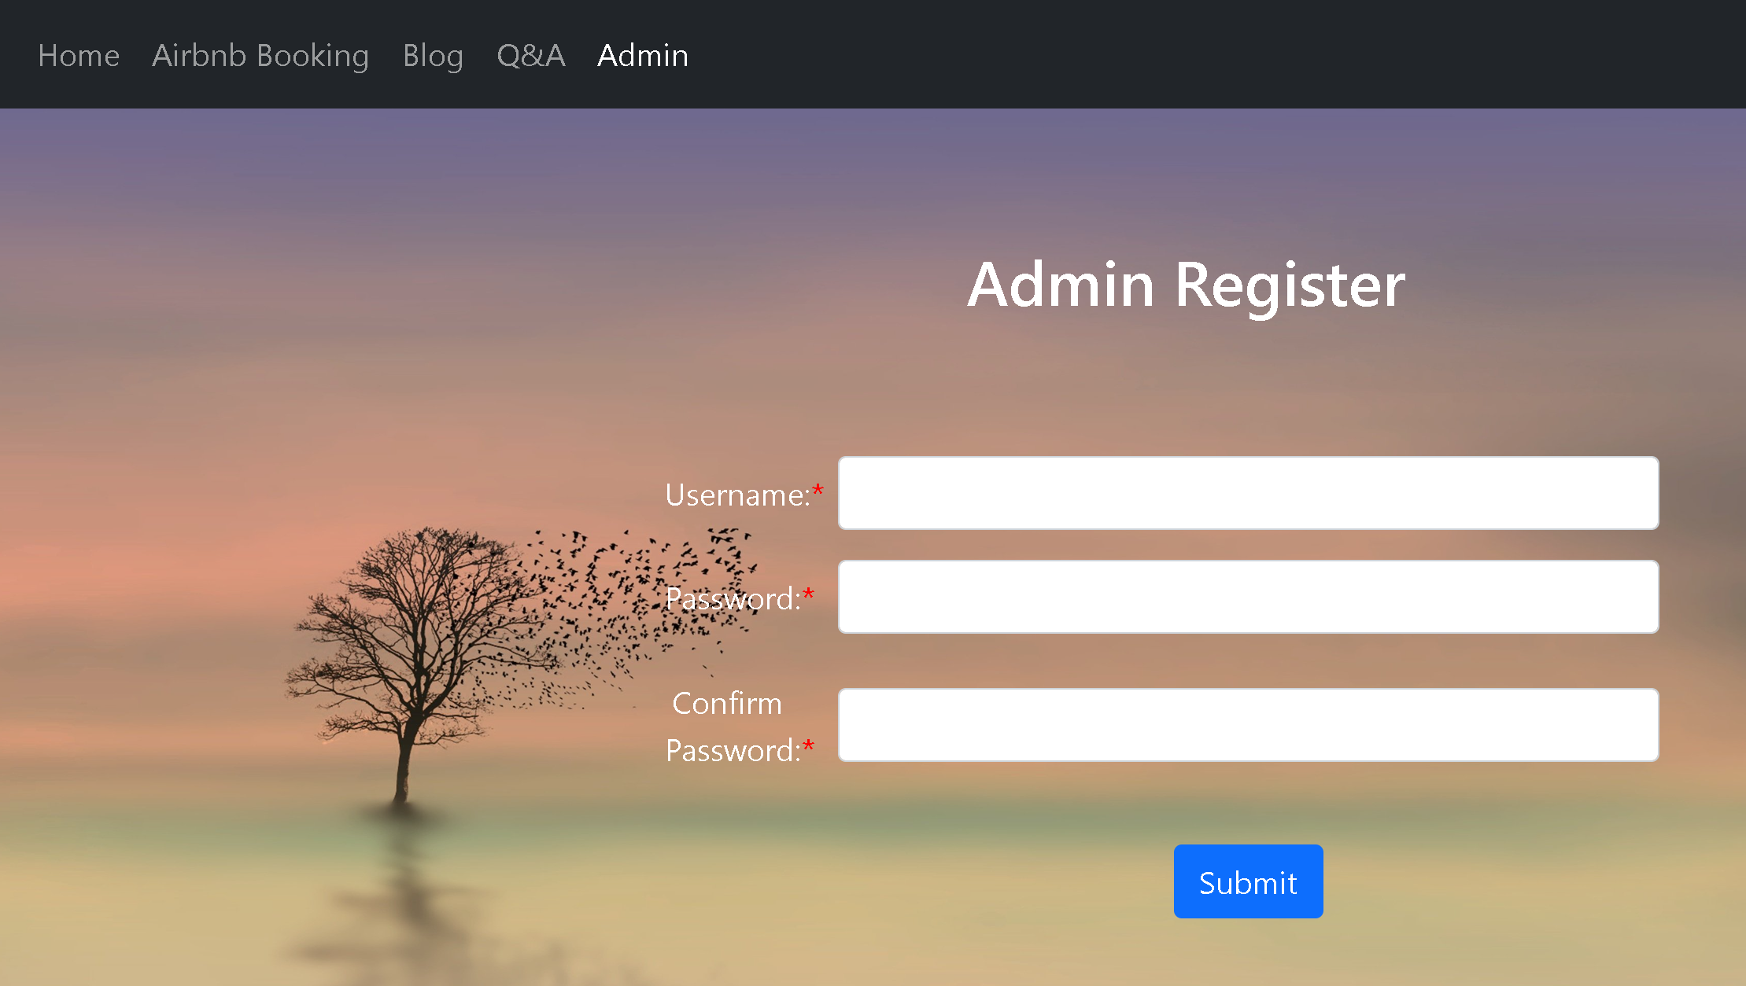

# Use Case Design

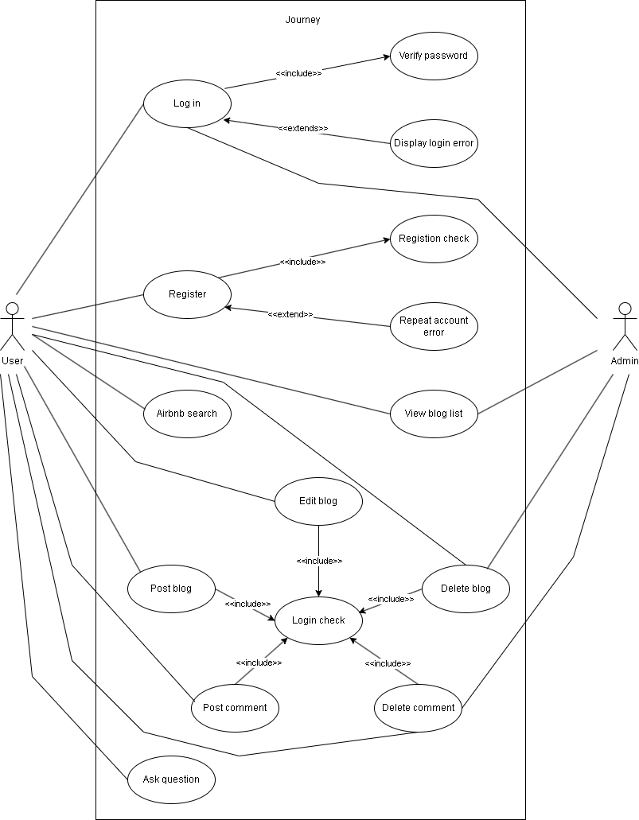

# Gantt Chart

|  |  |  |  |  |  |  |  |
| --- | --- | --- | --- | --- | --- | --- | --- |
| **Role** | **Macro Task** | **Micro Task** | **Start Date** | **End Date** | **Pre-Conditions** | **Comments** | **Status** |
| **Infrastructure** | **Construct  project frame** |  | 8/10/2023 | 8/10/2023 |  |  | **completed** |
| **Third party interfaces  invoking  module** | Weather interface | 8/10/2023 | 8/10/2023 |  | Permit browser to get latitude and longitude | **completed** |
| AI interface | 8/10/2023 | 10/10/2023 | Apply an AI  account |  | **completed** |
| Airbnb room interface | 10/10/2023 | 10/10/2023 | Search suitable third-party interfaces |  | **completed** |
| **Database  module** | Create mysql  database on AWS | 12/10/2023 | 12/10/2023 | Register an  AWS account |  | **completed** |
| Introduce Mybatis  framwork | 15/10/2023 | 15/10/2023 |  |  | **completed** |
| **Business logic** | **User module** | Home page frontend | 28/12/2023 | 28/12/2023 |  |  | **completed** |
| Show weather information | 29/12/2023 | 29/12/2023 |  |  | **completed** |
| Register page  frontend | 30/12/2023 | 30/12/2023 | Test the interfaces |  | **completed** |
| Register process backend | 31/12/2023 | 31/12/2023 |  |  | **completed** |
| Login process backend | 31/12/2023 | 31/12/2023 |  |  | **completed** |
| Logout process backend | 31/12/2023 | 31/12/2023 |  |  | **completed** |
| **Blog module** | Blog list  page frontend | 1/1/2024 | 1/1/2024 |  |  | **completed** |
| Blog detail frontend | 1/1/2024 | 1/1/2024 |  |  | **completed** |
| Editor detail frontend | 2/1/2024 | 2/1/2024 |  |  | **completed** |
| Comment page frontend | 2/1/2024 | 2/1/2024 |  |  | **completed** |
| Airbnb room  search frontend | 2/1/2024 | 2/1/2024 |  |  | **completed** |
| **Admin  module** | Admin page frontend | 3/1/2024 | 3/1/2024 |  |  | **completed** |
| Admin register and login backend | 3/1/2024 | 3/1/2024 |  |  | **completed** |
| **Operation and maintenance** | **Dynamic service  deployment** | Deploy the  project on AWS | 4/1/2024 | 4/1/2024 | Apply a AWS  instance | Install sdkman to simplify the process | **completed** |
| Bind domain  to the server | 4/1/2024 | 4/1/2024 | Buy a domain |  | **completed** |
| **Static service  and network** | Deploy Nginx for  the static server | 5/1/2024 | 5/1/2024 |  | Listening to the port 443 and 80, transfer request to port 8080 | **completed** |
| Generate and use  SSL certificate | 6/1/2024 | 6/1/2024 |  | Generate a free SSL certificate by Certbot | **completed** |

# Technical Specification

The third-party APIs used in the project are **weather information**, **Airbnb listing queries**, and artificial intelligence-based Q&A. All these APIs are encapsulated by the backend, while the back-end server provides new APIs to the frontend. The weather information API uses the current location of the browser, so you need to allow the browser to provide the current location to it.

The front-end of the project uses **jQuery** for the JavaScript manipulation and uses **Bootstrap** for the page style.

The back end uses **Maven** to manage the project's build; uses **Spring Boot** as the core framework; uses **JSP** to generate the HTML page; uses **MyBatis** to generate and operate SQL sentences to store and select data; uses **JPA** to build data table automatically. The database is **MySQL**, which is hosted on RDS, a free online database service of AWS.

# Deployment Strategy

The project is deployed on a free server provided by **AWS**, using port **8080** due to AWS restrictions on ports below 1024. **Nginx** serves as a static server for request forwarding, redirecting HTTP and HTTPS requests to port 8080.

SSL encryption is implemented using **Certbot** to generate a free SSL certificate, ensuring secure HTTPS requests. The website's domain is purchased from the domain registrar Namecheap and linked to AWS Cloud Platform's DNS for access via the domain name.